Final Project – MIS2402 – Fall 2025
Now that you have experience writing HTML and JavaScript code of your own, you are in a better position to use AI tools to help you create web applications.
In this project, you will use an AI tool to create two simple web applications. The first application will be the same for every student. The second will be a creation that is unique to you.
Check Canvas for the project due date.

Scenario
In this project, you will ask an AI to create two special-purpose calculators. A “special purpose” calculator is a web application that takes one or more inputs and generates a useful result. An example of a special-purpose calculator would be a loan repayment calculator, not a general-purpose four-function calculator.

Special Purpose Calculator  GOOD  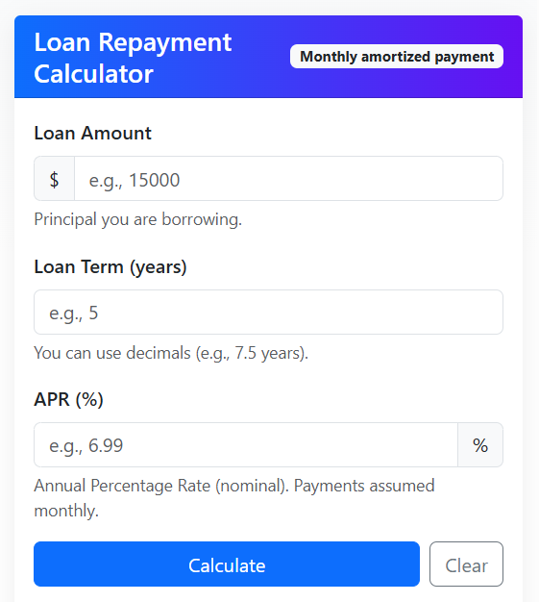 |  | Basic Calculator  BAD - Don’t make one of these  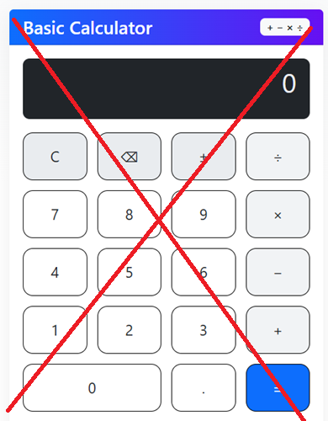

Instructions – Part 1
- Pick an AI chat application. Some possible choices: ChatGPT https://openai.com/chatgpt , Google Gemini https://gemini.google.com , Venice AI https://venice.ai or any similar application. (You should not have to pay anything / subscribe to anything for this project!)
- You must use the AI prompt in the appendix of this document to write the code for a loan repayment calculator.
- Log in to misdemo.temple.edu using Bitvise.
- Navigate to your www root and create a project folder. Inside that folder, create a file named index.html
cd wwwroot
mkdir project
nano index.html

- Copy / Paste your AI-generated code into your index.html file and save it.
- Determine the URL to your work. Notice that the file name index.html is special. It is respected as the default html file in a folder. That means that your URL does not need to end with index.html .
Test your work using a URL like this:
https://misdemo.temple.edu/<<username>>/project
- Test your work. It may not work on the first try. Fixing it is up to you. You can make fixes yourself, or by interacting more with the AI chat application. If necessary, erase your code in nano and then copy/paste your code into nano again as needed.
HINT: You can delete a whole line of text in nano with control K. Pressing control K repeatedly is a quick way to delete lots of text in nano.

- Test your work. It is not acceptable for your solution to use JavaScript alerts or prompts as shown below.
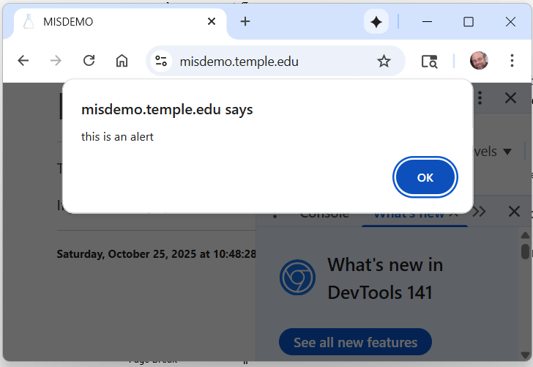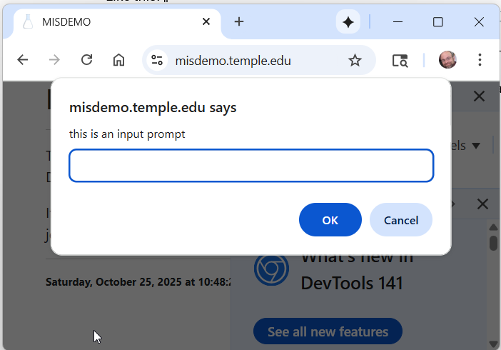

CONTINUED

- Test your work. You code should make accurate calculations. Test for one or more simple (and easy to verify) values before you try complicated ones.
  - $100 loan, with 1% interest, paid over 5 years has a monthly payment of $1.71
  - $10,000 load, with 10% interest, paid over 10 years has a monthly payment of $132.15
- Test your work. Your code should validate input and present meaningful messages to the user when the user input is missing, out of bounds, or non-sensical.
Recall that using the JavaScript alert() and prompt() functions is not acceptable.

Instructions – Part 2
Now that you have a working loan repayment calculator, it is time for you to create a special-purpose calculator of your own. You are required to be creative here. Students are expected to individually come up with their own ideas.
- You need to imagine a calculator that could be used for finance, investment, health, project management or any other legitimate purpose. You are not allowed to repeat class material. (For example: you worked on a BMI calculator earlier this semester, you are not allowed to repeat that.)
- Edit the prompt found in the appendix of this document, replacing the yellow highlighted portions with your own text.
- On misdemo.temple.edu, enter the following commands
cd ~
cd wwwroot
mkdir project2
cd project2
nano index.html
- Copy and paste the code for your own special-purpose calculator into the index.html file.
- Determine the URL for your work.
- Test your work just as thoroughly as you did in Part 1. You are responsible for making any necessary fixes.

CONTINUED

Turn in your work
Fill in the boxes below. Note that the first two boxes prompt for URLs. Each URL should start with https:// and the URL should end with a folder name (not .html)
The third box is your opportunity to explain the purpose of the calculator you created in part 2.
URL #1 – Loan repayment calculator:
https://misdemo.temple.edu/tur84371s/project

URL #2 – You own special-purpose calculator
https://misdemo.temple.edu/tur84371s/project2

Describe your special-purpose calculator. What’s it for? Why would anyone want to use it?
My calculator is called the Aptitude Test Time Manager. It is designed to help students prepare for competitive aptitude exams by showing them how much time they can afford to spend on each question and what their estimated score might be based on their expected accuracy. The user enters the total number of questions, the total time available, how accurate they think they will be, and the marks per question. The calculator then displays the time per question, the estimated number of correct answers, and an estimated total score. People would want to use this tool because time management is one of the biggest challenges during exams like IIT entrance tests, college aptitude tests, or placement test assessments. Many students struggle to decide how fast they need to work, whether they should focus on accuracy or speed, and how to plan their answering strategy. My calculator gives a clear breakdown of pace and performance and even generates a suggested strategy based on the numbers. This makes it helpful for exam preparation, practice sessions, and improving both accuracy and pacing before the real test.

Rubric
Item | Description | Points *
1 | URL 1 works on the first try / first click | 10
2 | URL 1 Calculator works with good input | 10
3 | URL 1 Appropriately responds to bad input | 10
4 | JavaScript alert() and JavaScript prompt() are not used. | 10
5 | URL 2 works on the first try / first click | 10
6 | URL 2 Calculator works with good input | 10
7 | URL 2 Appropriately responds to bad input | 10
8 | JavaScript alert() and JavaScript prompt() are not used. | 10
9 | Special purpose calculator is thoughtful, imaginative, and/or useful. | 20
* Points are awarded on a “all or nothing” basis, except for Item 9 which is evaluated at the instructor's discretion in 5-point increments ranging as follows:
0 (very poor) 5 (poor) 10 (Adequate) 15 (good) 20 (very good)

MIS PRO Points
Students who earn a grade of 85% or higher on this project are eligible to receive 50 MIS PRO points. Students will be notified by their instructor if they are eligible.
If eligible, students must request the PRO points using the MIS community site.

Appendix
Ask the AI to make you a calculator using the prompt below. (Note that this is a special-purpose calculator )
Create a web page that uses JavaScript, jQuery, HTML, CSS, and Bootstrap to implement a loan repayment calculator.
Given a loan amount, a loan term (in years), and an annual percentage rate (APR), calculate a monthly payment, the total amount paid, and the total amount of interest paid.
Here are some specifications:
- Present the user with an HTML form and get the loan amount, the loan term (in years) and the annual percentage rate from the user.
- Use this input to calculate the monthly payment, the total amount paid, and the total amount of interest paid.
- Assume that payments are made on the loan reliably each month
- Store the HTML, CSS, and JavaScript in a single file. This solution must be contained entirely in a single index.html file.

- Reference Bootstrap using the free, publicly available, most recent, most reliable CDN
- Reference jQuery using the free, publicly available, most recent, most reliable CDN
- Use jQuery to manipulate the HTML where needed
- The bootstrap layout should be a 2 span column, 8 span column, 2 span column layout with the calculator in the middle
- Do not use HTML buttons of type submit. Use JavaScript click events only.

